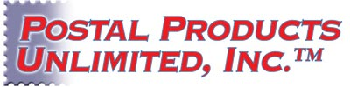
Care and Cleaning
Important Product Info

The surface of all Postal Products Manufacturing clear aluminum or powder coated products may be cleaned of dirt or grime with a soft cloth dampened with any mild detergent or properly diluted biodegradable, water-based cleaner, such as “Simple Green™”. Wipe from top to bottom avoid run-down. Avoid use of abrasives, which might damage the product surface. Rinse with plain water and dry. Avoid cleaning during extreme temperature conditions.

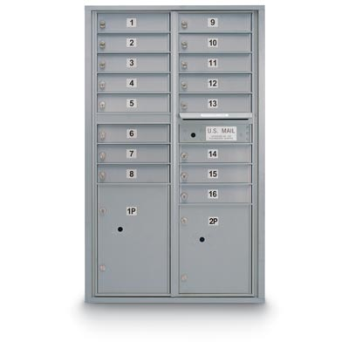
To varying extents, depending upon the color, it may be possible to remove some spray-paint or marker-applied graffiti from powder coated surfaces by using a stronger cleaner such as “Krud Kutter™” or a mild petroleum-based solvent, such as mineral spirits. Test-clean a small area first, a few seconds at a time. Do not allow chemical to remain on surface for an indefinite period, as this may damage the surface of the product. Remove any residue left with a mild cleaner, followed by water rinse as noted above.

Matching touch-up paint products may be available from an Authorized Postal Products Dealer for products which utilize powder coat finishes.

If a mailbox lock in outdoor equipment becomes clogged with ice due to extreme winter conditions, the lock manufacture suggest using “Tri-Flow® Superior Lubricant Aerosol”. Spray the Tri-Flow® Lubricant directly into the keyhole and onto the key. Slide the key in and out of the lock several times to spread the lubricant. Do not apply much product, as a small amount is sufficient. Wipe off any excess lubricant from the lock and key.

